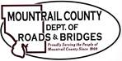
March 15, 2022
Action Items:

- CR9 phase II
- Proposed two-year construction phasing
- R&T utility relocation cost update

- Pickup rotation / quotes

- Plaza Complex Commercial Inspection results

Ongoing Items:
Williams County Road / 60th ST NW (Myrtle / Unorganized Township T155-94 shared section line)
Plaza Shop

