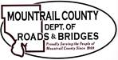
December 5, 2023

- CR10 / project # 10(51)23
- Bid Opening Results

- 213 – R&B Capital Construction Fun

Ongoing business:
- Salt & Sand Storage Area

