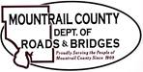
November 2, 2021
Action Items:

- BRO_0031(056) Cottonwood Lake Structures
- Requested Action: Please approve land values for ROW acquisition.

- CR15 / 15(82)21
- Requested Action: Approve to advertise for bids.

- 96th AVE NW / Wise Road Weather Station

- 76th AVE NW / CR 3 – Extension Request

