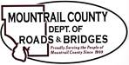
November 21, 2023

- Wm. D. Scepaniak, Inc

- NDDOT
- County Maintenance Certification for county federal aid projects

- Construction Engineering Agreement (Sauber Engineering)
- Request to increase the NTE – CR12
- Request to increase the NTE – Bridge 31-106.25.0

Ongoing business:
- Salt & Sand Storage Area

