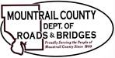
November 11, 2022
Action Items:

- 03(76)19
- Final Pay app
- Waiver and Release of Liens

- White Earth_ ROW Exhibits

- The Transportation Road Advisory Committee

- 2024 Professional Engineering - suggestions

- Temporary Use of ROW (flat water hose permit)

