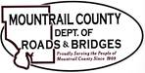
October 3, 2023

- NDOT Federal Funds Form

- CR10 - Wetlands

- Review of Haul Route and Excess Load Agreements – Bonds

- Parking Lot - striping

- 2023 Traffic Count Info

- R&B Sign, Bridge and Culvert Database

Ongoing business:
- Salt & Sand Storage Area
- Rail Road Crossing

