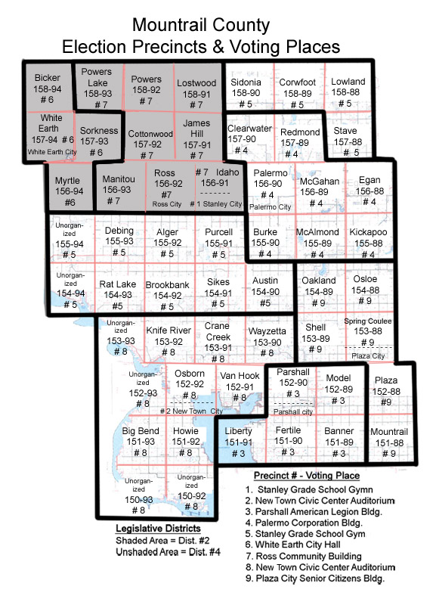PROCEEDINGS OF THE MOUNTRAIL COUNTY PARK COMMISSION

February 20, 2025

The Board met in special session on Thursday at 8:15 A.M. with Commissioners Wayne Olson, John DeGroot, Jason Rice, Eric Jaeger present, Arden Eide via GoToMeeting. Wade Enget, State’s Attorney was absent. Also present was Jared Iverson with White Earth Bay.

Chairman Jaeger called the meeting to order.

**PARSHALL BAY, VAN HOOK & WHITE EARTH DISCUSSION:**

Moved by Comm. DeGroot, seconded by Comm. Olson, to approve sending the annual management plans (AMP) to the Corps for Parshall Bay, Van Hook & White Earth Bay. Upon roll call, all present voted yes. Motion carried.

Moved by Comm. DeGroot, seconded by Comm. Rice, to approve the plans submitted by Dale Fredrickson with Lot 7, White Earth Bay for the installation of rip rap. Upon roll call, all present voted yes. Motion carried.

The Board adjourned at 8:26 A.M. to meet in regular session on Thursday, March 20, 2024 at 9:00 A.M.

Accepted and approved this 20th day of March, 2025.

Eric Jaeger

Mountrail County Park Commission

ATTEST:

Stephanie A. Pappa

Mountrail County Auditor