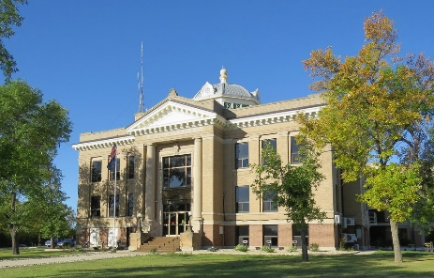

www.co.mountrail.nd.us Mountrail County Planning & Zoning

P&Z Number ________________________

P&Z CUP Number ________________________

Parcel Number of Data center _________________

Parcel Number of dwelling ____________________

Consent Form

Data Centers within a 1 mile

Of all single-family and multi-family dwellings, schools, churches, synagogues, and other similar religious institution or structures, and public parks

TO WHOM IT MAY CONCERN:

LET IT BE KNOWN THAT:

(NAME OF ALL LANDOWNERS)

PROPERTY OWNER OF ______________________________________________________
______________________________________________________________________________
(PARCEL NUMBER & LEGAL DESCRIPTION)

AND

(DATA CENTER PARTIES)

PROPERTY OWNER/LESSOR OF __________________________________________________

_____________________________________________________________________________
(PARCEL NUMBER & LEGAL DESCRIPTION)

ARE IN AGREEMENT THAT ALL PARTIES ARE GOOD WITH ALLOWING A DATA CENTER TO BE BUILDT AND OPERATED WITHIN THE 1 MILE SETBACK. ALL ARE AWARE THAT DATA CENTERS ARE AN INDUSTRIAL USE.

*REFER TO THE MOUNTRAIL COUNTY LAND DEVELOPMENT ORDINANCE.

SIGNED: _ DATE: _________________
Landowner

SIGNED: _ DATE: _________________
Landowner

SIGNED: _________________________________ DATE:_______________________
Data Center

STATE OF )
) §
COUNTY OF )

On this day of 20 , ___ __ personally appeared before me, known to me to be the person described in and who executed the within and foregoing instrument and acknowledge that he executed the same.

_____________________________

My Commission expires ___

STATE OF )
) §
COUNTY OF )

On this day of 20 , ___ __ personally appeared before me, known to me to be the person described in and who executed the within and foregoing instrument and acknowledge that he executed the same.

_____________________________

My Commission expires ___

This document is required to be recorded with the Mountrail County Recorder

