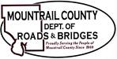

- Pavement Striping / Quote

- Plaza Lift Station Update

- Cr 3 Fencing Change Order

- (Equipment) Sourcewell MB Paint Truck

Ongoing:
- 29th ST NW
- Sanish Encroachments
- ROW
- MWEC

