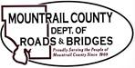
April 2, 2024

- USGS
- Hydrologic Monitoring Well – located in County ROW

