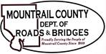
March 18, 2025

- Structure Replacement – Bridge No. 31-114-08.0, Project No. BR11408
- Certificate of Insurance discussion
- Construction Contract
- Notice to Proceed

Ongoing:
29th ST NW
Plaza – leaking roof

