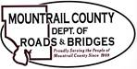
February 20, 2024
- Sauber Engineering
- BR10625 – Engineering Amendment No.2
- CR12 - Engineering Amendment No.2

- CR3/ Palermo North Project
- ROW Update

- 36th ST NW
- ROW Values
- Notice of Public Meeting and Notice of Environmental Assessment for Stanley Municipal Airport

- Plaza Shop – leaking roof

