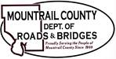
February 17, 2026

- BR11408 – Cottonwood Lake Structure Replacement
- Balancing Change Order
- Final Pay Application

- BNSF Request

- 2026 Frow Law

Ongoing:
- 29th ST NW
- Sanish Encroachments
- ROW
- MWEC

