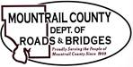

*DECEMBER 3, 2024*

1. **2025 Township Annual Road Maintenance Agreement**
2. **Purcell Township**
3. Request for Culvert Assistance
4. **MWEC Easement**