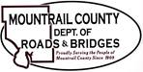
December 2, 2025

- CR14 Pavement Maintenance
- PE Contract

- 2026 Township Road Contracts

Ongoing:
- 29th ST NW
- Plaza – Leaking Roof
- Sanish Encroachments
- ROW
- MWEC

