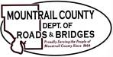

*October 15, 2024*

1. **CR10 – Baranko Companies**
2. Request: retainage reduction down to 1%
3. **36th ST NW –** Project Update
4. **Parshall SOV letter**
5. **NDDOT**
6. County Maintenance Letter
7. County Maintenance Form

**Discussion:**